Analysing Australian International Trade: Visual Analytics

Submitted By- Kushal Ahuja (14191922)

Table of Contents

Data Preparation 3

Understanding the sample trade dataset 3

Statistical Pattern 4

The Analytical Pattern 4

Time Series Charts 5

Interactive Chart 8

Dashboard 11

Storyboard 15

Summary 18

Conclusion 20

References 21

# Data Preparation

The Australian International Trade dataset extracted from ABS Statistics data contains data from 30 years, i.e. between 1988 and 2021. The dataset has import and export information, including 10 main categories and its 67 sub-categories. Each subcategory comprises productivity and resource usage among several industries or commodities.

Data preparation is an important task to be executed before working with any dataset, as then it provides accurate and valuable insights and information; Data preparation includes various steps like dealing with missing values, sorting the data and changing the data information according to the needs, In this dataset, the data preparation is done by making new sheets named Ratio (Statistical Pattern) and Changes (Analytical Pattern), these changes is made to analyse and visualise the Australian Trade Dataset according to the needs, I have also added the sheet named Combine which consists data of the import and export sheet for better comparison and understanding of the information.

These changes to the data are made because of the different scales of data across the categories and sub-categories, for example, the total in millions ($) varies. To combat this and visualise the data efficiently, Statistical Pattern and Analytical Pattern are created.

## Understanding the sample trade dataset

The dataset consists of two sheets, i.e. import and export of Categories and Sub-Categories for the period of 30 years (1988-2021),

The 10 main categories include:

1. Food and live animals

2. Beverages and tobacco

3. Crude materials, inedible, except fuels

4. Mineral fuels, lubricants, and related materials

5. Animal and vegetable oils, fats and waxes

6. Chemicals and related products

7. Manufactured goods classified chiefly by material

8. Machinery and transport equipment

9. Miscellaneous manufactured articles

10. Commodities and transactions not classified elsewhere in the SITC

The two sheets Import and Export values are combined in one sheet named Combine to deploy it in tableau for clear comparison between the new pattern percentage, the new patterns created are explained below-

## **Statistical Pattern**

Statistical patterns use mathematical techniques such as sum and divide to measure the percentage of an individual category or subcategory with the overall total.

The statistical pattern of Categories is calculated by dividing the value of commodity imported or exported in a certain year by the total amount, whilst the statistical pattern of Subcategories are calculated by dividing the value of certain sub-categories by their respective category in the same year.

For categories X=1 to 10, the percentage of each category can be found from

Percentage (x-Import) = sub-total (x-Import) / Total (Import)

Percentage (x-Export) = sub-total (x-Export) / Total (Export)

Where total Percentage (x-Import) and Percentage (x-Export) should be 100%

The statistical pattern for sub-categories can be calculated in a similar way except in the place of total; it will be category value.

These values found by trade type, i.e. import and export, will be then merged in a single sheet called Ratios.

## The Analytical Pattern

The analytical pattern is created to measure particular imports and exports between categories and subcategories; the analytical pattern is created; it is also created to measure the yearly change for the particular category and subcategory. The Analytical pattern is called Change.

Change (t) = a(t) / a(t-1)

where a(t) is data for category (x) or sub-category (y) and t = year(1988, 1989, …, 2021).

Note:

1. There is an exception. No previous year data can be found before the year 1988. Thus, all the values in 1998 will be 100%.

2. All the #Div/0! Values are replaced with 0%. (As division with zero is not possible)

# Time Series Charts

This time-series chart is created to visualise statistical patterns between import and export for the ten main categories; for better understanding and interaction, various chart types are included in this time-series chart, like polygon for the 10th category, i.e., Commodities and transactions, Area, Line and bar-charts for other categories. There are some interesting insights gained from this chart like -

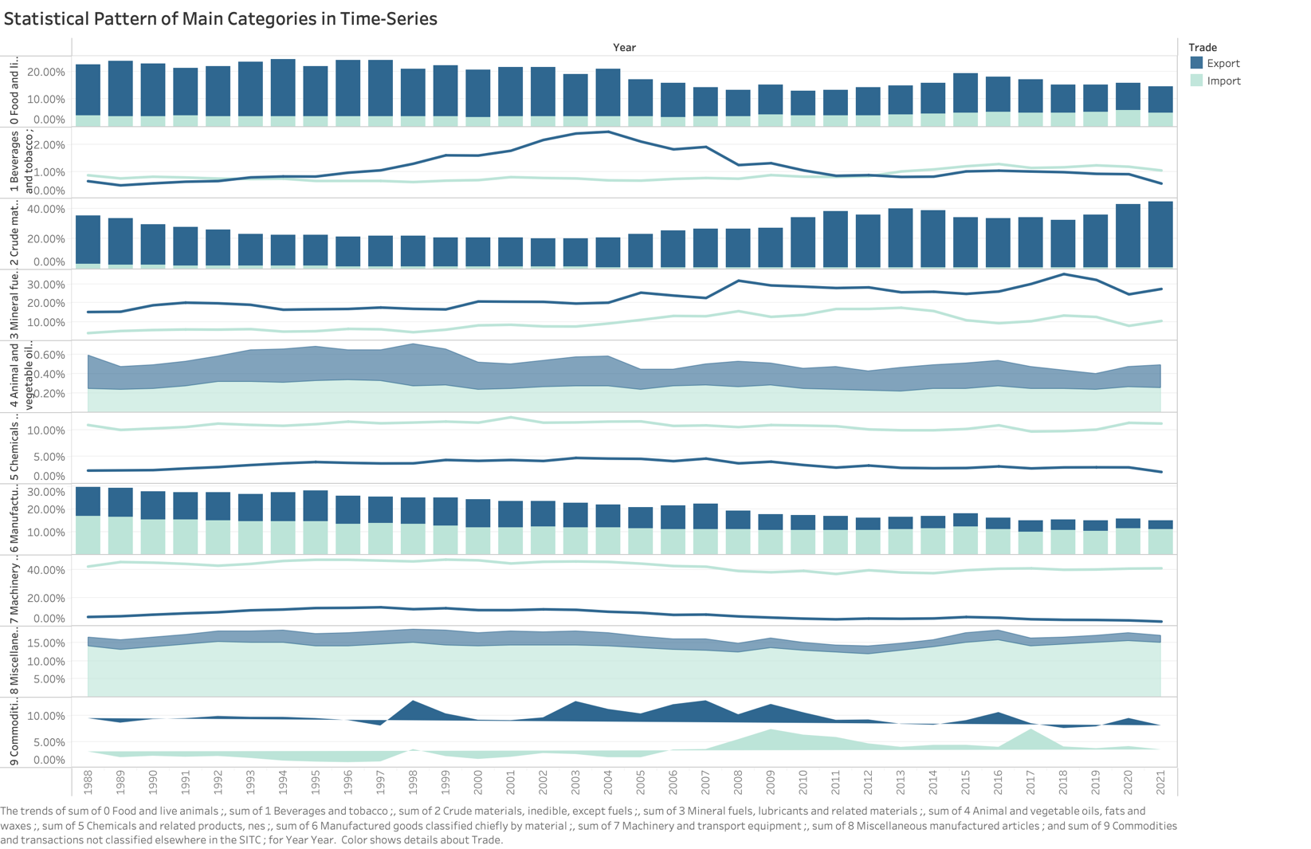

Figure 1: The Statistical Pattern for All Main Categories

* The imports of Machinery and transport equipment are much larger than the exports while in contrast the imports are much less compared to exports in the Chemicals and related products and in Crude materials, inedible, except fuels.
* The import and export ratio has grown similarly for the category of Mineral fuels, lubricants, and related materials.
* The export ratio for the categoryManufactured goods classified chiefly by the material has declined since 2007.
* Similar changes between export and import in the year 2009 have been witnessed in the category of Commodities and transactions.
* The surge was witnessed in the category - Beverages and tobacco from 1994 to 2004 and then a decline trend was seen resulting in more imports than export for this category.

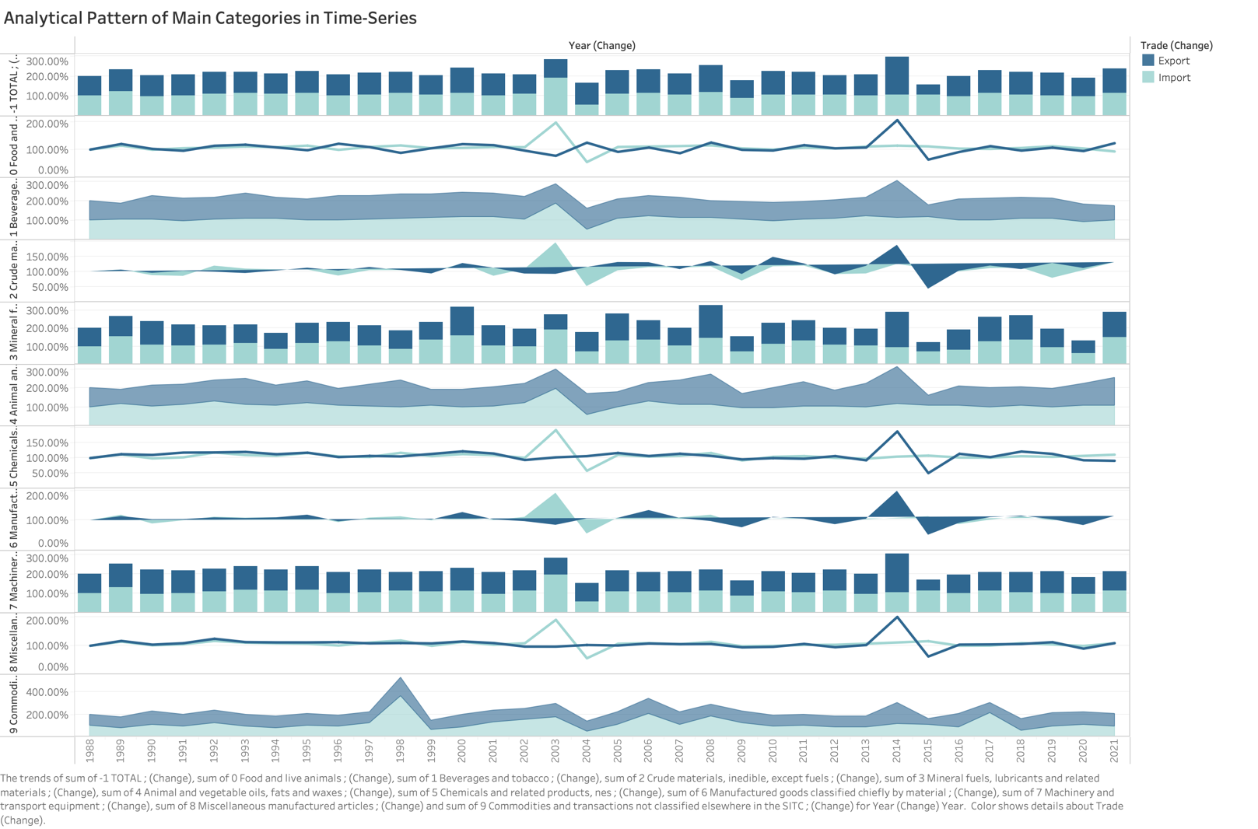

Figure 2: The Analytical Pattern for All Main Categories

This time-series chart is created to visualise analytical patterns between import and export for the ten main categories; for better understanding and interaction, various chart types are included in this time-series chart, like a Polygon chart, Line, Area and Bar-charts.

The insights gained from this visualisation are-

* Similar trends occurred in the years 2003 and 2004; the import got increased in 2003 and then dropped in 2004 for all the categories; the reason for this surge in Import was the rise in the Australian dollar exchange rate as it was cost-efficient to import the products rather than making in the own nation.

* The rise in the export ratio occurred in 2014 for all the categories due to Australia’s free trade agreement with China, Japan and Korea.
* Overall, it is evident from figure 2 that the change in import and export for every category was similar. Moreover, the export and import were balanced except for the years 2003 and 2014.

# Interactive Chart

Interactive charts are used to demonstrate the various attributes in a single chart; they are helpful for comparing the two or more attributes in one graph .

**Figure 3 & 4: Line chart and Area chart for Import of Main Categories in Time-series

The above figures demonstrate the import percentages of Main Categories in two forms –

* Line Chart – The left figure is the line chart denoting the import percentage of ten main categories; the insights gained from the line chart are-
  + Machinery and transport equipment is the major contributor to the import in Australia, it account more than the combination of various other categories, stating information that the nation has less Machinery and Transport equipment resource made in their own region. This category accounts for almost 37% - 45% of imports every year.
  + The import of Animal and Vegetable Oil is the least for all the years, stating that the country is least depended on Animals and Vegetable Oil from other nations and is also capable of making it in their own region.
  + The import ratio of the category Mineral fuels, lubricants, and related materials increased drastically from 1998 to 2013 from 4.47% to 17.51%, thus providing the information that the country was in need of more products related to this category.

The Area chart states the same insights with different illustrations in the form of percentages, as it provides the overall share in the form of percentages; for example, the major contributor to the import was Machinery and transport equipment, therefore in the chart, it accounts for most of the space. This form of interactive chart is easy to understand and visualises the data in a better way.

Figure 5: Line chart for Export of Main Categories in Time-series

The above figures demonstrate the export percentages of the Main Categories in the Line chart-

It is found from the visualisation –

* Crude materials, inedible, except fuels, accounts for most of the export and has increased in the last decade, particularly between the years 2009 and 2011, with a change of around 10%. It is interesting to note that the export of this category witnessed a drastic decline from 1998 to 1993 with a drop of around 11%.
* Mineral fuels, lubricants, and related materials export has been risen from 15% to 35.49% in 2018, proving the growth of the resources in Australia and dominance in the global market. But it dropped to 24.68% in 2020 due to the decrease in coal and mineral fuels prices. Thus other nations also started to supply to the global market and reduce the overall demand for the same.
* The declining trend is noticed for the export of categories - Food and live animals, Commodities and transactions and Manufactured goods classified chiefly by material over the last decade.

Figure 6: Area chart for Export of Main Categories in Time-series

The Area chart states the same insights with different illustrations in the form of percentages, as it provides the overall share in the form of percentages.

It provides the information in the form of stacked, i.e. providing the data in the form of overall share compared to all the other categories. This form of interactive chart is easy to understand and visualises the data in a better way.

# **Dashboard**

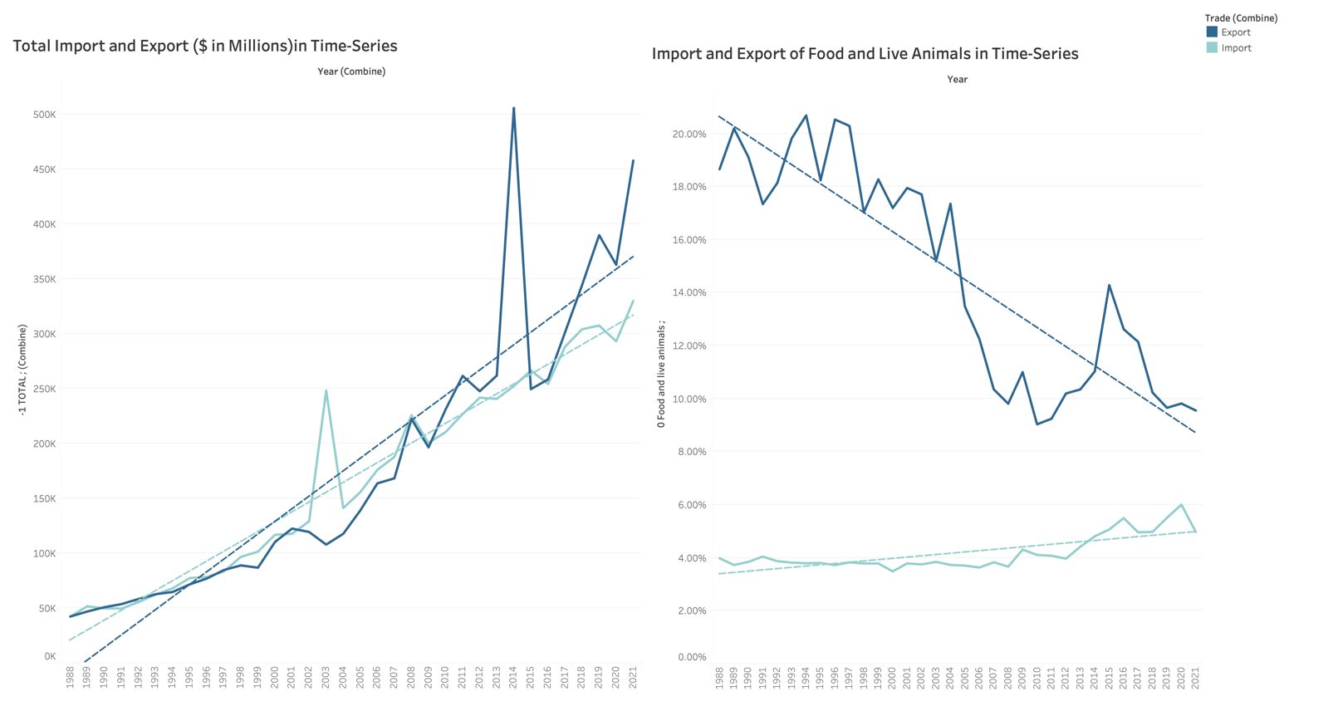A dashboard is a visualisation technique for combining various kinds of graphical data. A dashboard's objective is to portray different, related data that stakeholders must be able to interpret easily and quickly. A dashboard is a way of combining the worksheets in a single frame. (What Is a Dashboard? A Complete Overview, n.d.)

Figure 7: Dashboard 1 stating the Import and Export of All the categories Vs Food and Live Animals Category

This dashboard provides a clear understanding of Food and Live Animal's import and export ratios compared to the total of all categories. It is evident from the graph that both import and export increased for all the categories over the period of 30 years, with some major fluctuations in 2003, 2014 and 2020 due to various reasons, while the export of Food and Live Animals reduced from 20% to around 10% and its import has been increased in the last decade stating the information that Australia may be in the shortage of the resources included in this category.

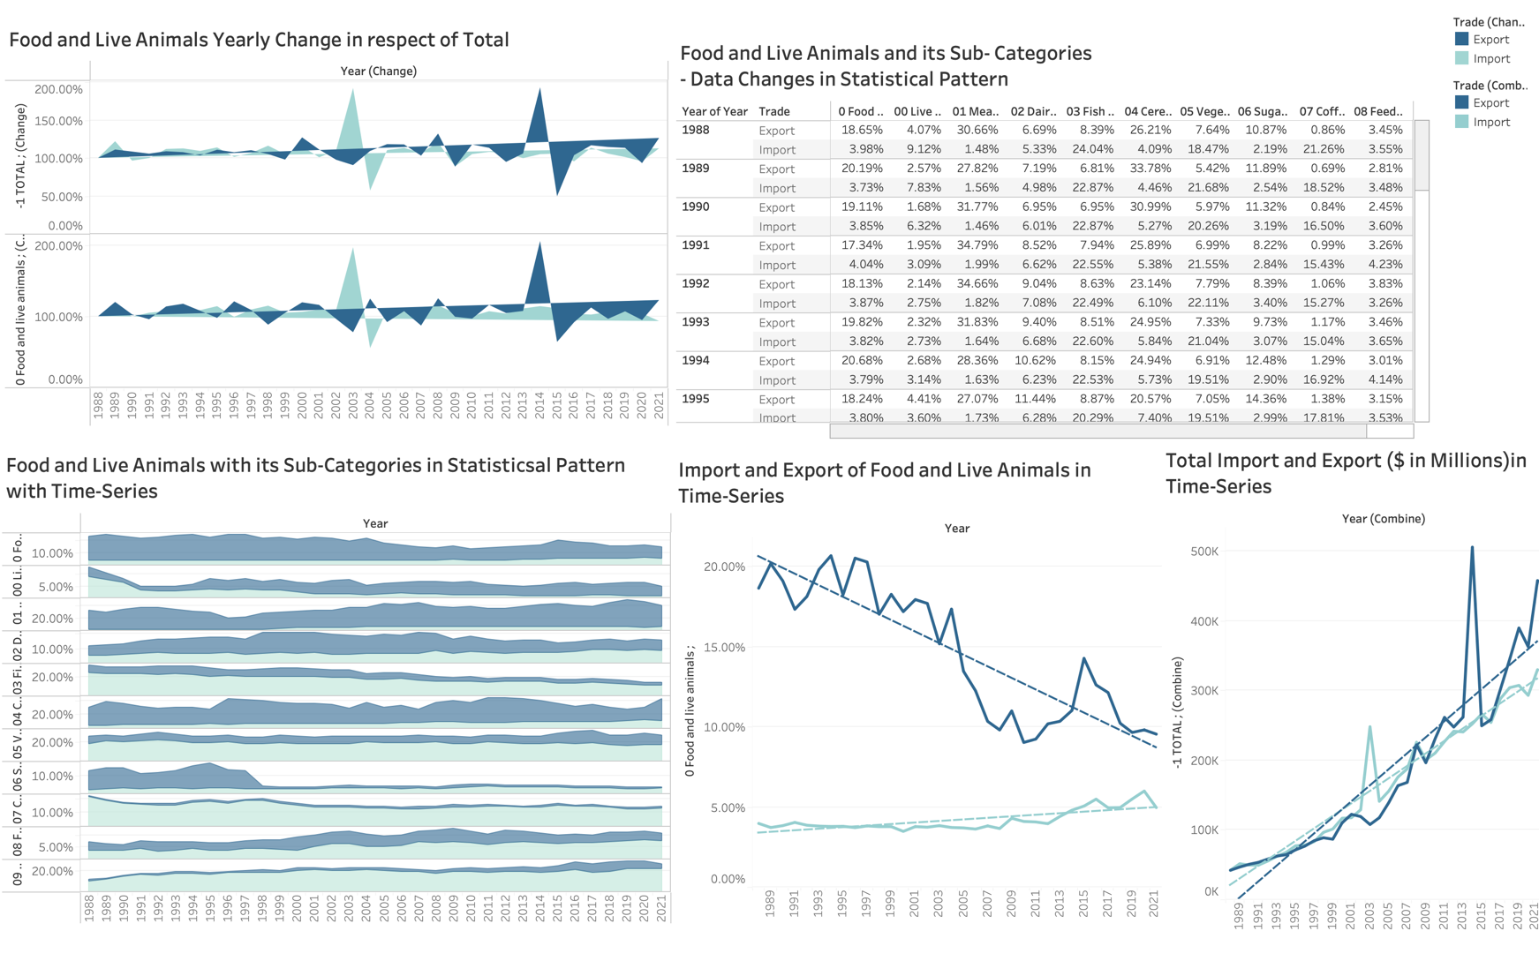

Figure 8: Dashboard 2- Changes in the Food and Live Animals and their Sub-Categories in Statistical Pattern (Time-Series)

The above dashboard combines the data of statistical patterns and overall Import and export for the category Food and Live Animals with its Sub-Categories for better understanding; due to the availability of various charts in a single dashboard, it is easier to analyse the information and also can be comprehended in less time.

This dashboard is made with a combination of a Polygon chart, Data-Table, Area Chart and Line Chart. It is evident from the graphs that they provide similar information in different forms like there has been a surge in imports in the year 2003, while in contrast, there was a surge in export in the year 2014 for the categories and subcategories, it also elaborates more information for import and export for the sub-categories of Food and Live Animals.

This information on the sub-categories is seen in the bottom left area chart, which also states that there has been more export than an import for the majority of the sub-categories.

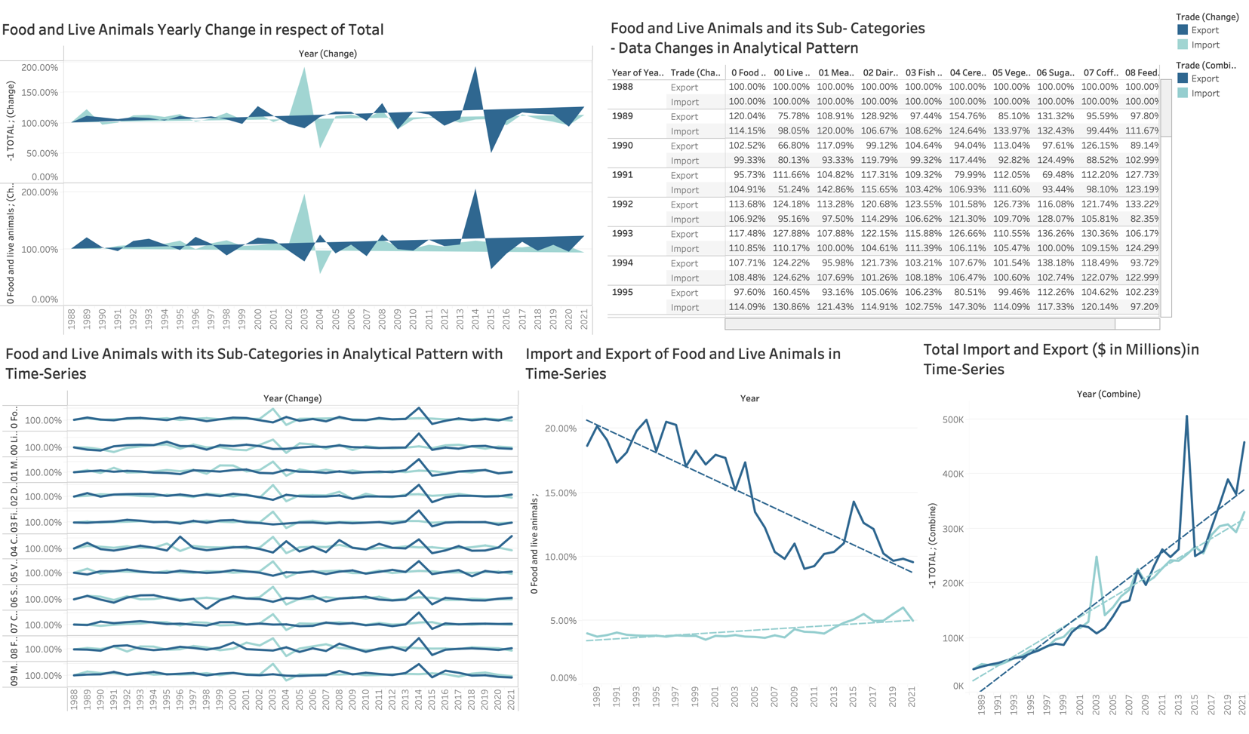

Figure 9: Dashboard 3- Changes in the Food and Live Animals and their Sub-Categories in Analytical Pattern (Time-Series)

The above dashboard visualises the analytical pattern of Food and Live Animals and its sub-categories; it includes a Polygon chart, Data-Table, Area Chart and Line Chart. It is evident from the graphs that they provide similar information in different forms like there has been a surge in imports in the year 2003, while in contrast, there was a surge in export in the year 2014 for the categories and subcategories, it also elaborates more information for import and export for the sub-categories of Food and Live Animals in the bottom-left line chart

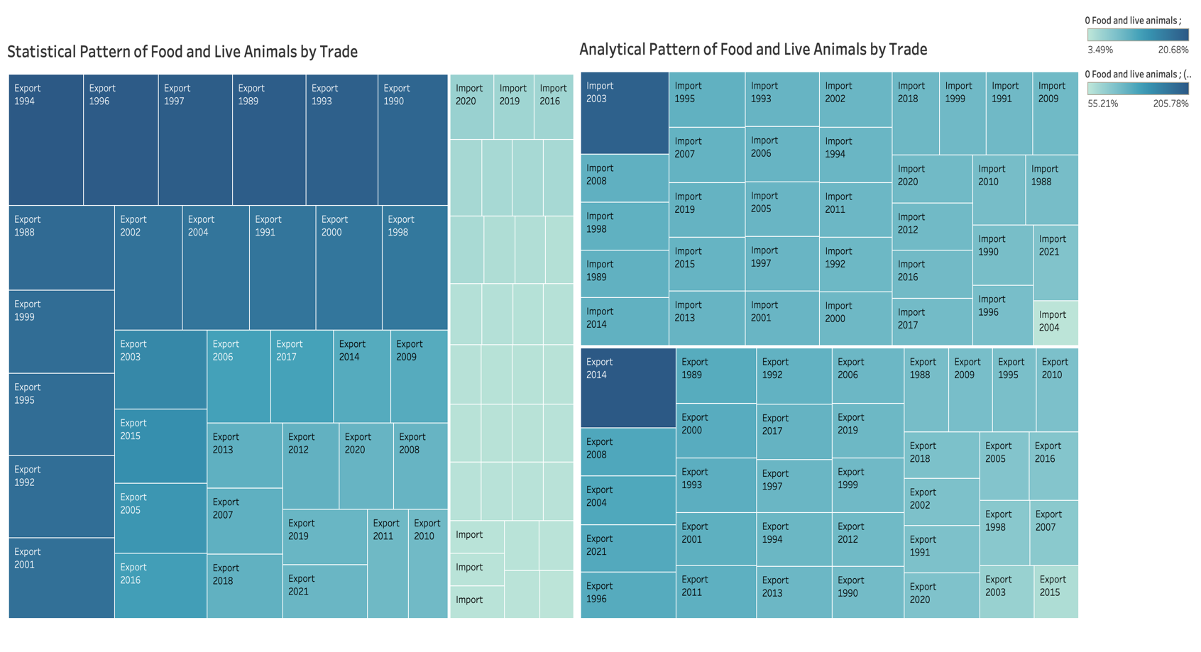Figure 10: Dashboard 4- Changes in the export and import of Food and Live Animal Category

The above dashboard is made with the treemap; The treemap is here used to display the years having higher to lower export ratio and import ratios. Treemaps are the perfect way to visualise the hierarchal data and create interesting insights; the two tree maps are for analysing the statistical pattern and analytical pattern, respectively.

It is evident from the above dashboard that the export for the ’90s is more than that of recent decades in respect of the statistical pattern. While for the analytical pattern, the import ratios are more compared to the export.

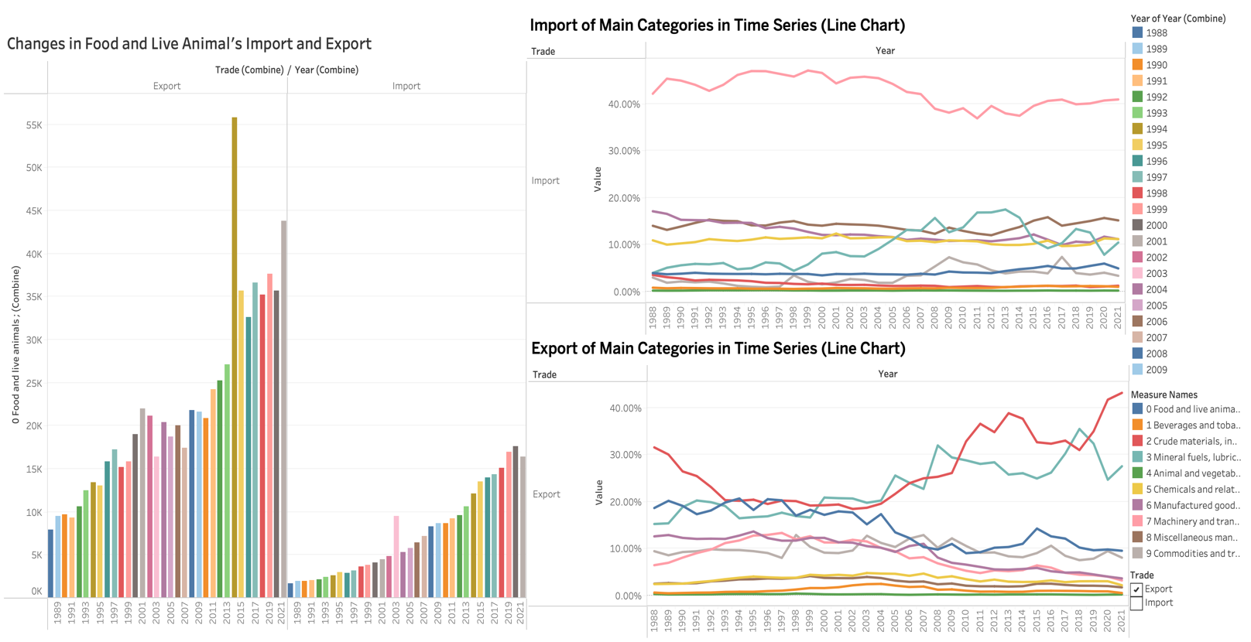

Figure 11: Dashboard 5 – Changes in Food and Live Animals Category with the changes in the main category

This dashboard provides a thorough change in the import and export of the Main Categories (Right) and Food and Live Category (Left); it is evident from the graph that the export was much greater than the import for the Food and Live Animal providing with the information that Australia has many resources in the category of Food and Live Animals, there was a sudden surge in the export of Food and Live Animal in the year 2014 due to the free trade agreement of Australia with China, Japan and Korea.

# **Storyboard**

A storyboard is a combination of worksheets, individual charts and dashboards that work together to tell a story. These stories can be used as an interactive tool to present complicate data in a simpler format. It creates more functions for users to understand the data; it is beneficial for both the stakeholder and the user.

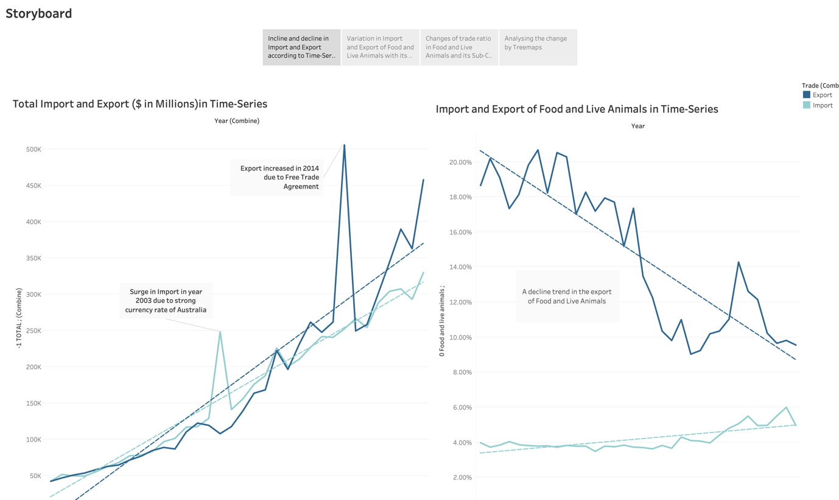

Figure 12: Storyboard- Incline and decline trend in the import and export of All and Food and Live Animals

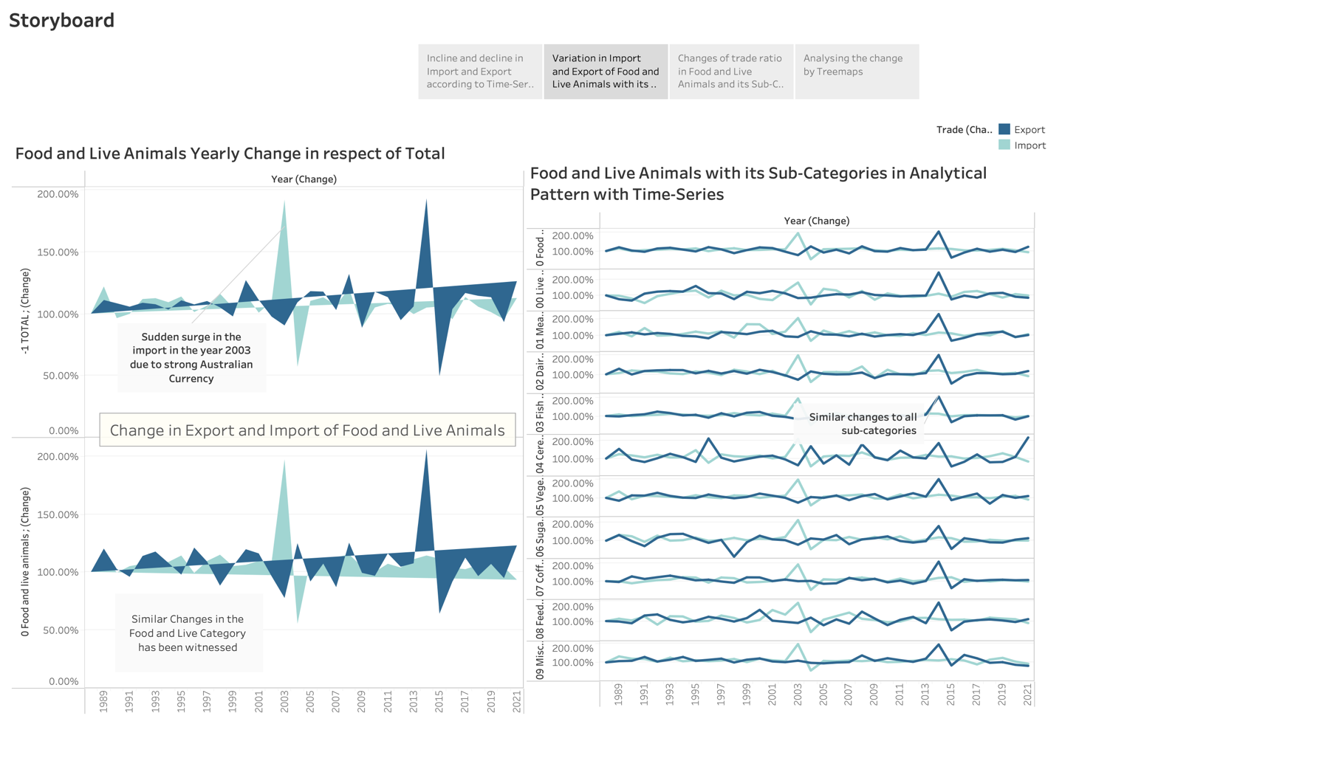The above storyboard tells the story of the import and export of all the categories in the line chart (Left) and for Food and Live Animals in the Line Chart (Right). The Annotate function makes the mark and tells the story for the interesting insights gained through the visualisations.

Figure 13: Storyboard- Changes in Import and Export of Food and Live Animals with its Sub-Categories

The above storyboard states the information of category Food and Live Animals with its Sub-Categories; it is evident from the storyboard that similar changes have been witnessed for the import and export when compared to the All category, Food and Live Animals and its Sub-Categories.

The reason for the surge in the import for the year 2003 is the robust Australian currency in respect of the global exchange currency rate. Thus it was cost-efficient to import the goods rather than make in its own region; therefore, the Australian government decided to opt for more imports in the particular year, thus making better use of the advantage of the currency.

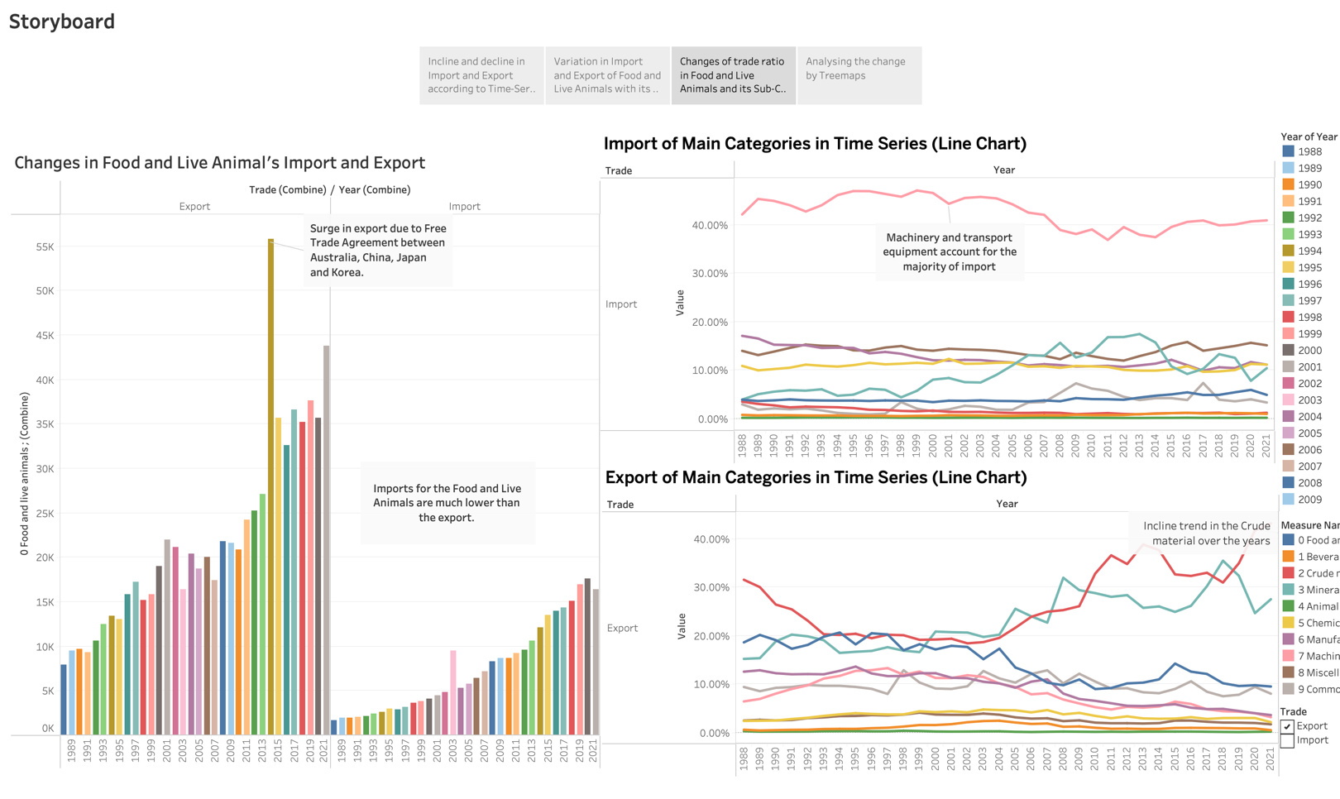The reason for the surge in export for the year 2004 is the Free Trade Agreement signed between four nations, i.e., Australia, China, Japan and Korea. This agreement was established to create better connections between the nations in respect of finance and consumer goods; every country benefited from the agreement due to fewer expenses on many commodities. This also enlarged the consumer experience due to a broader range of products under many commodities.

Figure 14: Storyboard- Changes in Import and Export of Food and Live Animals with the Main Categories

The above storyboard states the information changes in Bar-chart (Left) and Line-Chart (Right); this visualisation is easy to interpret and present to the stakeholders. The interesting insights have been marked through the annotate function. The scale for the Food and Live Animals Category graph is changed to the original i.e. in dollars for better comparison and understanding of the trade types.

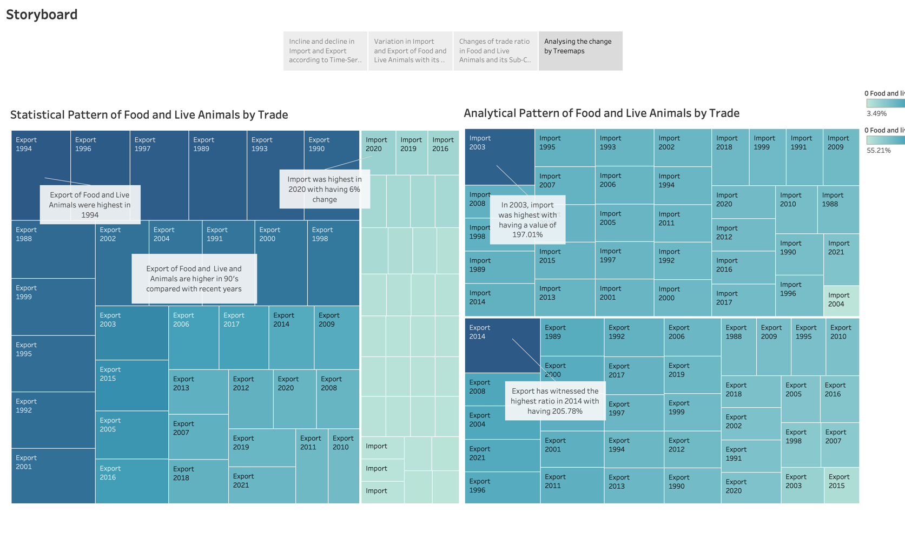

Figure 15: Storyboard- Changes in Import and Export of Food and Live Animals with the Main Categories

The above storyboard is made with the treemap of statistical patterns and analytical patterns; This illustration provides a clear understanding of the Food and Live Animals in respect of the trade type and the respective year.

It is evident from the storyboard that the export in the ’90s is much more than the exports of other decades, proving the strong resources capabilities of Australia for Food and Live Animals in the ’90s, while in contrast, the import is more in recent years as seen in the statistical pattern.

# Summary

For analysing theAustralian International Trade dataset various visualisation techniques were used, but the main techniques were – Dashboard and Storyboard

**Dashboard**

In tableau, the dashboard is made by combining various sheets and conveying the relevant information; it is very useful for comparison between two patterns or categories; it can be done by making the same scale for all the charts included in the dashboard.

Dashboards can also be made interactive by adding a filter in the column, for example, adding a filter in trade only to show the export, then it can be added as a filter and thus, there will be options in the legends to choose the trade type, this makes the dashboard to be useful when focusing on many attributes at the same time.

**Advantages-**

**Multiple charts**- Adding multiple charts in a single frame is very beneficial for many users; it creates opportunities to understand the visualisation in the most efficient way. As in this dataset, it was easier to understand the Statistical pattern of Food and Live Animals with its sub-categories.

**Customisation** – A dashboard can be customised the way the user wants; it creates the flexibility to add filters, thus creating more opportunities for the user to make the best use of the visualisation tools.

**Storyboard**

The storyboard is similar to the dashboard with additional features; a user can tell the story with the visualisation created and portray the results in a better way; this can be done by adding more slides. The storyboard can also contain a dashboard and various charts in a single frame but with different slides.

**Advantages-**

**Additional Features**- The other visualisation techniques can only provide insights and generate trends, but the storyboard can also tell the story associated with that insight and the trend.

**Feature of captions-** The feature of creating various slidesthrough captions and adding the charts and dashboards in the single storyboard isvery beneficial**.**

# Conclusion

To conclude, the interactive charts, dashboards and storyboards have helped to reveal insights and portray interesting stories from the numerical dataset.

The insights and the valuable information found from the visualisation are-

* Both total imports and exports have increased over the years, the imports are increased by about 600%, and the export is increased by about 750%.
* The surge in Export in 2014 was because of the free trade agreement with China, Japan and Korea. This helped Australia in a monetary way as well as in improving the consumer experience with the commodities.
* The surge in imports in the year 2003 was because of the increase in the Australian Currency Rate, i.e. AUD in respect of the global exchange, resulting the advantages of Australia’s economy, due to the reason of cost-saving Australia imported most of the commodities rather than making it in their region; this has led to the short-term advantages.
* Machinery and transport equipment was the major contributor to the total import.
* The declining trend is noticed for the export of categories - Food and live animals, Commodities and transactions and Manufactured goods classified chiefly by material over the last decade.
* Crude materials, inedible, except fuels, accounts for most of the export and has increased in the last decade, particularly between the years 2009 and 2011, with a change of around 10%. It is interesting to note that the export of this category witnessed a drastic decline from 1998 to 1993 with a drop of around 11%.

# References

*What is a dashboard? A complete overview*. (n.d.). Tableau. <https://www.tableau.com/learn/articles/dashboards/what-is>

K, B. (2021, June 30). *Create a Tableau Story*. Rigor Data Solutions. <https://www.rigordatasolutions.com/post/create-a-tableau-story>

*Stories*. (n.d.). Tableau. https://help.tableau.com/current/pro/desktop/en-us/stories.htm